Stock Portfolio Tracker Using Python

Objective
To calculate the total investment value of stocks based on user input and predefined stock prices.

Software Used
- Python
- Visual Studio Code (VS Code)

Code

stock_prices = {

"AAPL": 180,

"TSLA": 250,

"GOOG": 150

}

stock_name = input("Enter stock name (AAPL/TSLA/GOOG): ").upper()

quantity = int(input("Enter quantity: "))

if stock_name in stock_prices:

total = stock_prices[stock_name] * quantity

print("Total Investment Value: $", total)

else:

print("Stock not found!")

Output
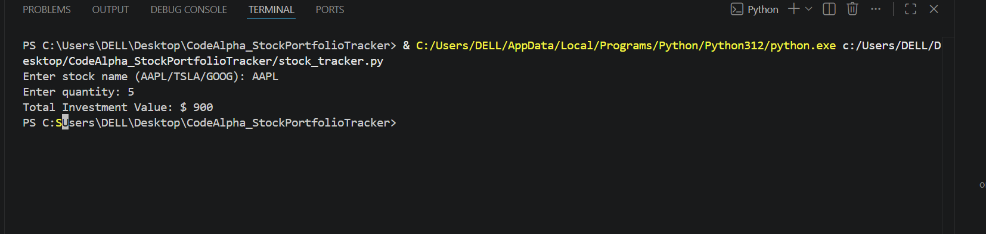

Explanation
1.Dictionary (stock_prices)
- Stores stock names and their prices.
2.input()
- Takes stock name and quantity from the user.
3.if-else Statement
- Checks whether the stock exists in the dictionary.
4.Arithmetic Calculation
- Multiplies stock price by quantity to calculate total investment value.

Features
- User-friendly input
- Calculates total investment value
- Uses predefined stock prices
- Handles invalid stock names

Conclusion
This project demonstrates the use of Python dictionaries, user input, conditional statements, and arithmetic operations to calculate stock investment values.

